

DRAFT
Technical Specification

Melbourne IT OFC
MIT OFC Supplier Approval Process

Author: Tony Whelan
Creation Date: 9 February 2017
Last Updated: 11 May 2017
Version: 1.0
Table of Contents

1. MIT Requirements 3
2. Proposed Solution 3
3. Configuration and Development 4
3.1 Define Responsibility 4
3.2 Assign System Profiles 4
3.3 Assign Responsibilities 5
3.4 Personalize Form 5
3.5 Define Alert 6
3.6 Define Pl/sql Package 9
3.7 Define Database Trigger 11
3.8 DBA Deployment Process 11
4. Functional Process 12
4.1 Create a Supplier or Supplier Site 12
4.2 Alert Emails 12
4.3 Approve or Activate a Supplier Site 13
5. Outstanding Issues 14
5.1 Alert Email Scheduling 14

MIT Requirements

Melbourne IT has a requirement to separate the creation and approval of Payables Suppliers. Currently the creation of Suppliers is done by the Billings Manager, but MIT require the creation to be done by Payables Officers and the approval to be done by the Billings Manager.

The Oracle AME Approvals Management module Version 12.1.3 does not cater for Payables Supplier creation approval, only for iSupplier module Supplier creation.

There is no existing Workflow Approval process for Supplier Creation and the estimated time to develop one would be 3 to 4 weeks development effort.

Proposed Solution

The Supplier form will be personalised to allow the Super User and Supplier Approver Responsibilities access to edit and update the Supplier Inactive Date field which will be set to Read-Only at the Site Level for all other Responsibilities.

An Email Alert will advise Approver Users that Suppliers and Bank Accounts have been created at 10:00 am and 2:00 pm every business day, and they can login and review the Supplier, Site and Banking Details prior to activating the supplier.

A Pl/sql package and database trigger will set the Supplier INACTIVE_DATE field to the system date when new Suppliers and Bank Accounts are created or existing Bank Accounts are updated.

Configuration and Development

Define Responsibility

Rename Responsibility MEL IT AU Payables Supplier Manager to MEL IT AU Payables Supplier Approver

Rename Responsibility MEL IT NZ Payables Supplier Manager to MEL IT NZ Payables Supplier Approver

Define Responsibility MEL IT AU Payables Supplier Creator and MEL IT NZ Payables Supplier Creator
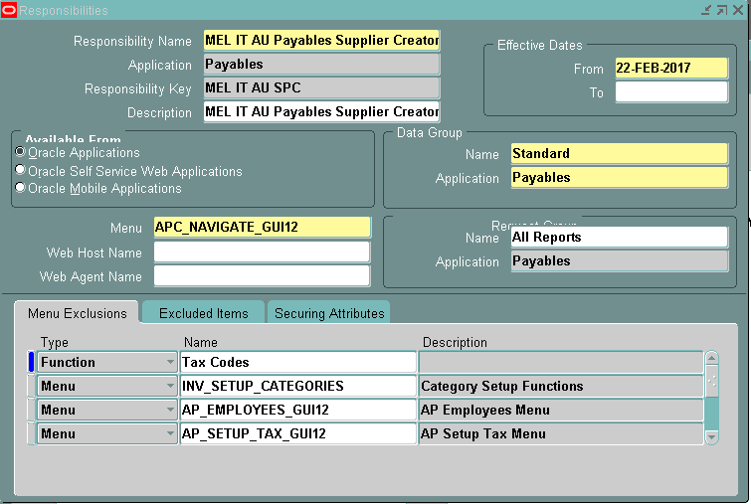

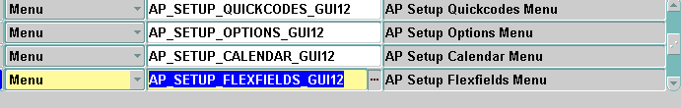

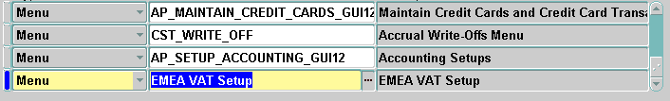

Assign System Profiles

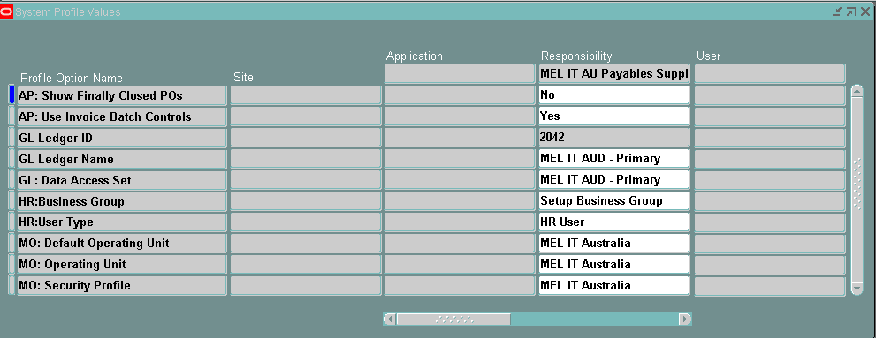

Assign Responsibilities
Assign the following responsibilities to User
User | Responsibility
STEPHEN.PICKWELL | MEL IT AU Payables Supplier Creator
STEPHEN.PICKWELL | MEL IT NZ Payables Supplier Creator
SU-ANN | MEL IT AU Payables Supplier Approver
ALEX | MEL IT AU Payables Supplier Approver
TONY.WHELAN | MEL IT AU Payables Supplier Approver
MICHELLE | MEL IT AU Payables Supplier Approver
SU-ANN | MEL IT NZ Payables Supplier Approver
ALEX | MEL IT NZ Payables Supplier Approver
TONY.WHELAN | MEL IT NZ Payables Supplier Approver
MICHELLE | MEL IT NZ Payables Supplier Approver

Personalize Form
Personalise the Inactive Date field in the Payables Supplier Form so the users of the responsibility below cannot modify it.

Field | Value | Responsibility
End Date: Read Only | True | MEL IT AU Payables Supplier Creator
End Date: Read Only | True | MEL IT AU Payables Enquiry Only
End Date: Read Only | True | MEL IT AU Payables Manager
End Date: Read Only | True | MEL IT AU Payables User
End Date: Read Only | True | MEL IT NZ Payables User

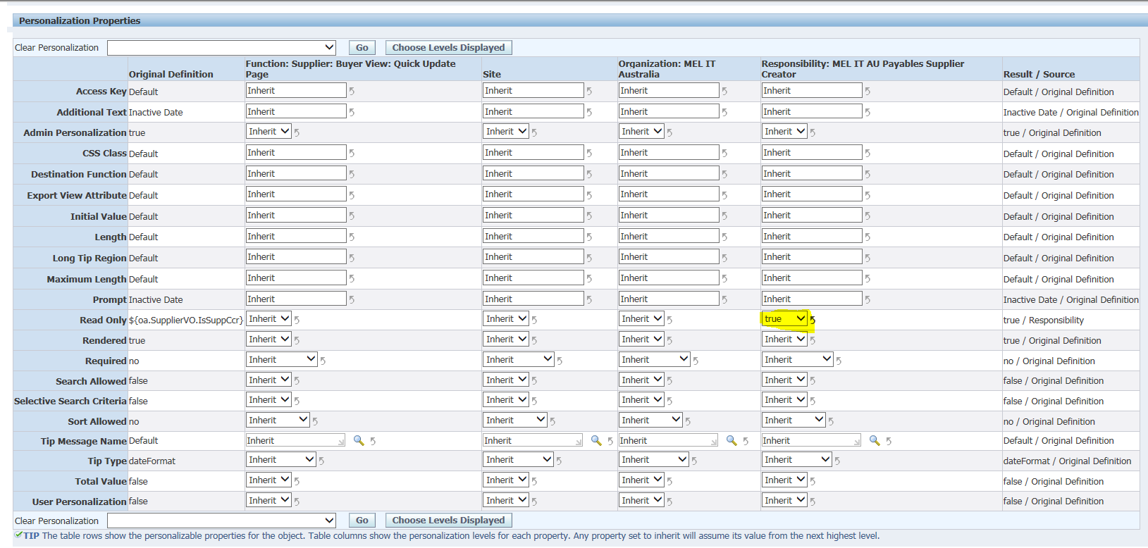

Define Alert
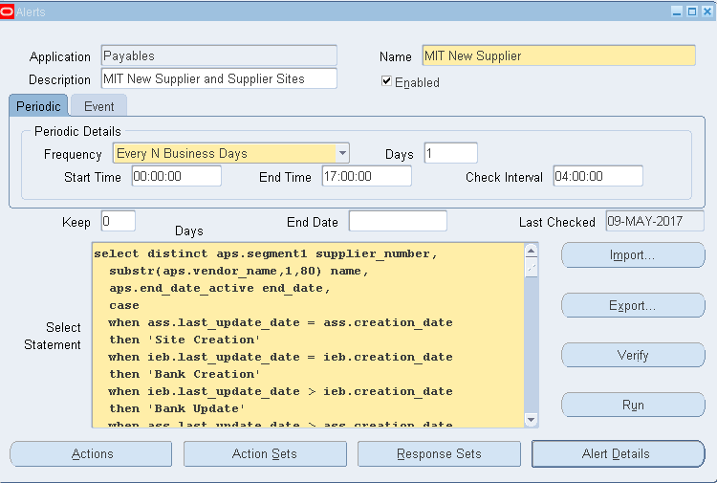

Select Statement:-
select distinct aps.segment1 supplier_number,
substr(aps.vendor_name,1,80) name,
aps.end_date_active end_date,
case
when ass.last_update_date = ass.creation_date
then 'Site Creation'
when ieb.last_update_date = ieb.creation_date
then 'Bank Creation'
when ieb.last_update_date > ieb.creation_date
then 'Bank Update'
when ass.last_update_date > ass.creation_date
then 'Site Update'
else
'Unknown Update'
end transaction_type,
ass.vendor_site_code,
initcap(ass.city),
ass.org_id,
nvl(ppf.full_name,fu.description) Supplier_Updated_By,
ieb.bank_account_name,
ieb.bank_account_num,
nvl(ppf2.full_name,fu2.description) Bank_Updated_By,
decode(vi.host_name,'sam.mit','OFC Production','findev2.melbourneit.com','OFC Development',vi.host_name) environment
into &supplier_number,
&supplier_name,
&end_date,
&transaction_type,
&site_code,
&city,
&org_id,
&supplier_update,
&account_name,
&account_num,
&bank_update,
&environment
from ap_suppliers aps
join hz_parties hp on hp.party_id = aps.party_id
join v$instance vi on 9 =9
join ap_supplier_sites_all ass on aps.vendor_id = ass.vendor_id
join hz_party_sites hps on ass.party_site_id = hps.party_site_id
left outer join fnd_user fu on ass.last_updated_by = fu.user_id
left outer join per_all_people_f ppf on ppf.person_id = fu.employee_id
join iby_external_payees_all iep on iep.payee_party_id = hp.party_id or (iep.party_site_id = hps.party_site_id and iep.supplier_site_id = ass.vendor_site_id)
join iby_pmt_instr_uses_all ipi on iep.ext_payee_id = ipi.ext_pmt_party_id
join iby_ext_bank_accounts ieb on ipi.instrument_id = ieb.ext_bank_account_id
left outer join fnd_user fu2 on ieb.last_updated_by = fu2.user_id
left outer join per_all_people_f ppf2 on fu2.employee_id = ppf2.person_id
where (nvl(ppf.effective_end_date,'31-DEC-4712') =
(select max( nvl(ppf3.effective_end_date,'31-DEC-4712'))
from apps.per_people_f ppf3
where ppf3.person_id = ppf.person_id
)
or ppf.effective_end_date is null)
and (nvl(ppf2.effective_end_date,'31-DEC-4712') =
(select max( nvl(ppf4.effective_end_date,'31-DEC-4712'))
from apps.per_people_f ppf4
where ppf4.person_id = ppf2.person_id
) or ppf2.effective_end_date is null)
and aps.end_date_active is not null
and (trunc(ass.last_update_date) > trunc(sysdate-7)
or trunc(ass.creation_date) > trunc(sysdate-7)
or trunc(ieb.creation_date) > trunc(sysdate-7)
or trunc(ieb.last_update_date) > trunc(sysdate-7));

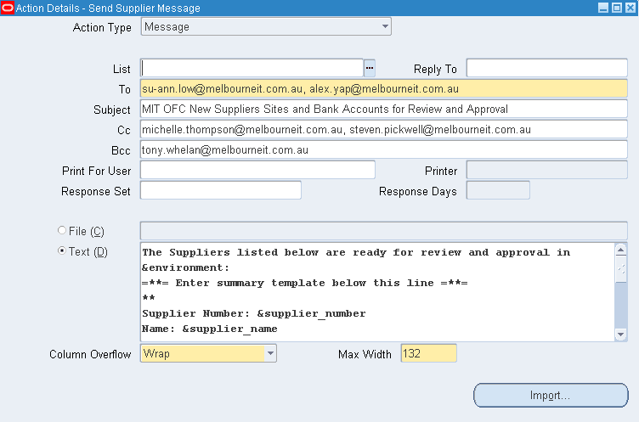

Text Field:
The Suppliers listed below are ready for review and approval in &environment:
=**= Enter summary template below this line =**=
**
Supplier Number: &supplier_number
Name: &supplier_name
End Date: &end_date
Transaction Type: &transaction_type
Site: &site_code
City: &city
Supplier Updated By: &supplier_update
Bank Account Name: &account_name
Account Number: &account_num
Bank Updated By: &bank_update
=**= Enter summary template above this line =**=

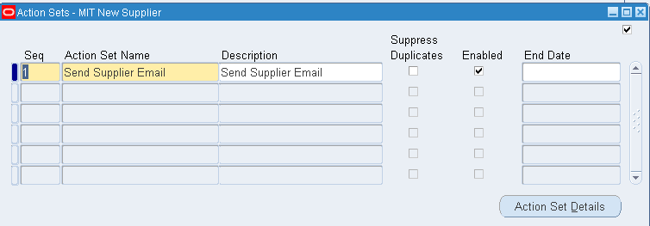

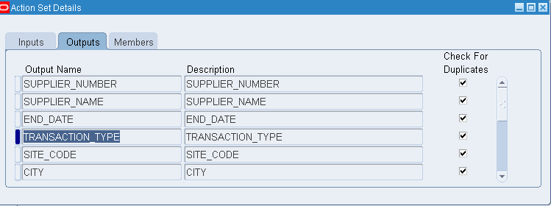

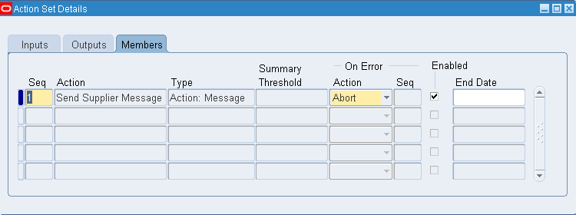

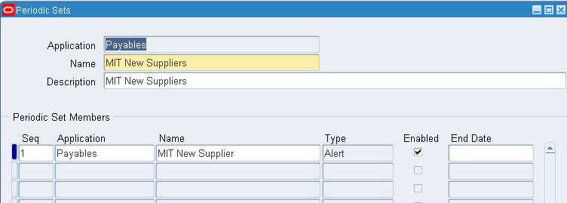

Define Pl/sql Package
This was required to circumvent mutating triggers error messages for triggers on the iby_ext_bank_accounts tables
--------------------------------------------------------------------------------
--Author: Tony Whelan
--Date: 31st March 2017
--Name: cr_mit_supplier_pkg
--Purpose: Required to implement separation of supplier creation and approval
--Called By: mit_enddate_supplier triggers
--Version: 1.0
--------------------------------------------------------------------------------
create or replace package mit_enddate_supplier_pkg
is
procedure init_data;
procedure insert_data(bank_acct_id in iby_ext_bank_accounts.ext_bank_account_id%type);
procedure update_data;
end;
/

create or replace package body mit_enddate_supplier_pkg
is
type bank_acct_table
is
table of iby_ext_bank_accounts.ext_bank_account_id%type index by binary_integer;
/* table type */
bank_acct_ids bank_acct_table;
/* table to store manager ids */
pos binary_integer;
/* table index */

procedure init_data
is
begin
pos := 0;
end;

procedure insert_data(
bank_acct_id in iby_ext_bank_accounts.ext_bank_account_id%type)
is
begin
pos := pos + 1;
bank_acct_ids(pos) := bank_acct_id;
end;

procedure update_data
is
begin

while pos > 0
loop
begin
update ap_suppliers
set end_date_active = sysdate,
last_update_date = sysdate,
last_updated_by = -1
where vendor_id in (
select aps.vendor_id
from ap_suppliers aps
join hz_parties hzp on hzp.party_id = aps.party_id
join hz_party_sites site_supp on hzp.party_id = site_supp.party_id
join ap_supplier_sites_all ass on site_supp.party_site_id = ass.party_site_id and ass.vendor_id = aps.vendor_id
join iby_external_payees_all iep on iep.payee_party_id = hzp.party_id
and iep.party_site_id = site_supp.party_site_id and iep.supplier_site_id = ass.vendor_site_id
join iby_pmt_instr_uses_all ipi on iep.ext_payee_id = ipi.ext_pmt_party_id
join iby_ext_bank_accounts ieb on ipi.instrument_id = ieb.ext_bank_account_id
where ieb.ext_bank_account_id = bank_acct_ids(pos));
exception
when no_data_found then
raise_application_error(-20000,'There are no Suppliers with Bank Acct ID: '||bank_acct_ids(pos));
end;
pos := pos - 1;
end loop;
end;
end;
/

Define Database Trigger
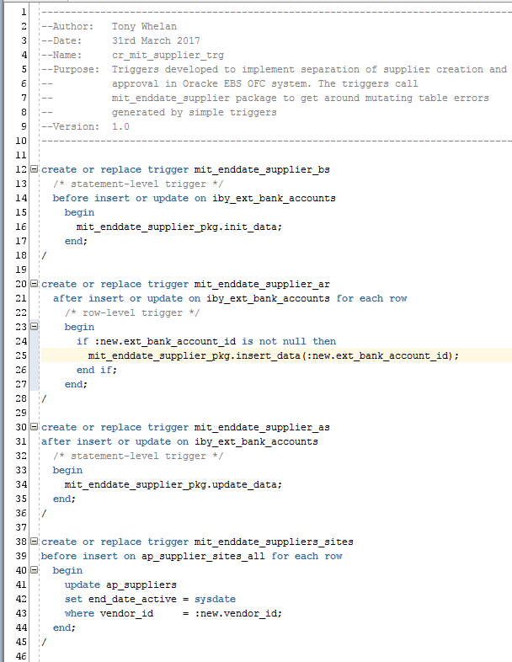

DBA Deployment Process
- cp cr_mit_supplier_pkg.sql $MIT_TOP/sql/cr_mit_supplier_pkg.sql
- cp cr_mit_supplier_trg.sql $MIT_TOP/sql/cr_mit_supplier_trg.sql
- sqlplus apps/password
- @cr_mit_supplier_pkg.sql
- @ cr_mit_supplier_trg.sql

Functional Process

Create a Supplier or Supplier Site

Login using MEL IT AU Payables Creator Responsibility
You can create new Suppliers if you have the above responsibility, or you can make changes to existing Suppliers.

Enter a new Supplier or Site using the Supplier Entry form
Enter the Supplier Information
Enter the Supplier Address Book Information
Enter the Supplier Site Information
Enter the Supplier Banking information

The new Supplier will be created or updated with an Inactive Date set to the current date. The Creator responsibilities do not have access to remove the Inactive Date.
This must be done by the Approver Responsibilities.
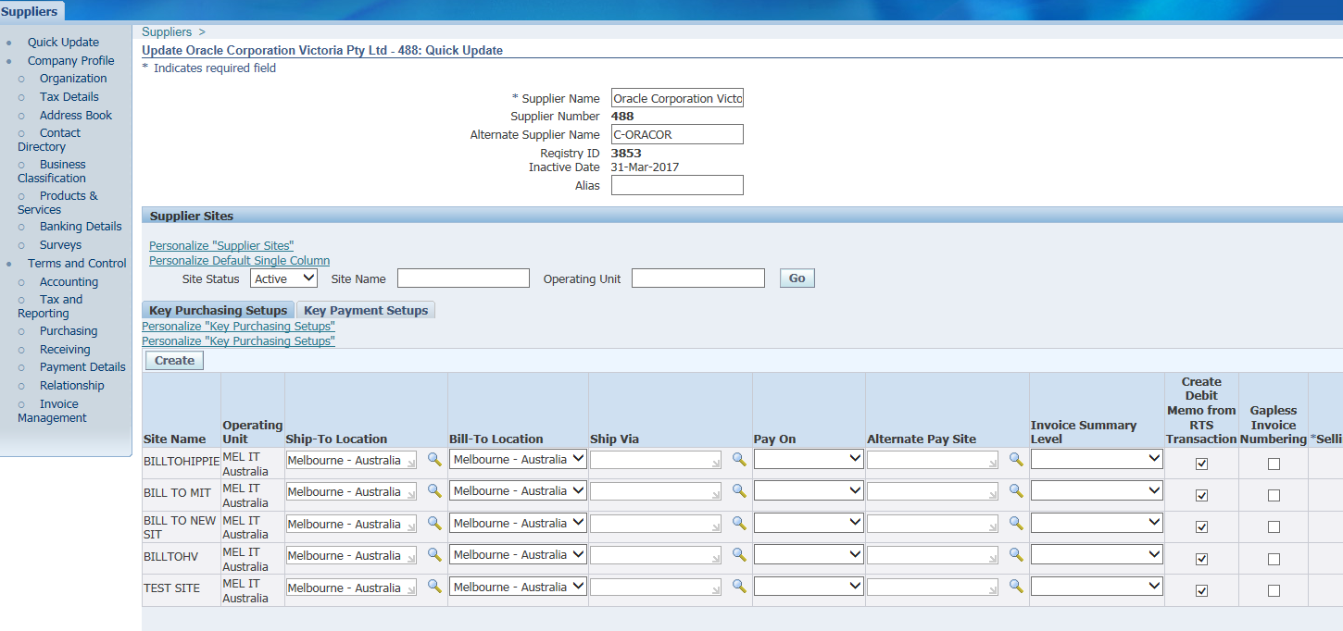

Alert Emails
An Alert Email will be sent to users with the MEL IT AU Payables Approver Responsibility every 4 hours on business days.

The Alert Email lists the new Suppliers and Sites that have been created in the last 7 days with a status of Inactive.

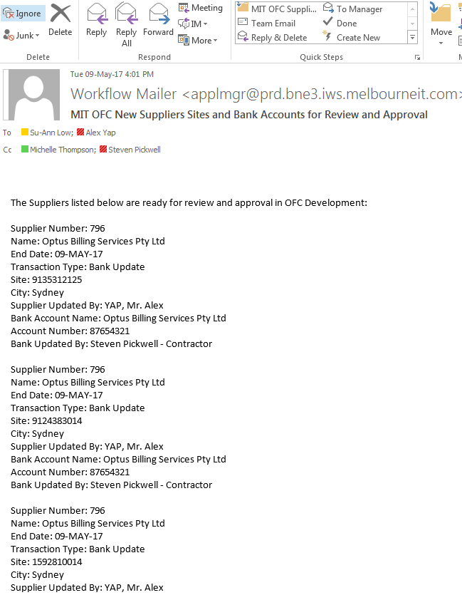

Approve or Activate a Supplier Site

Login as MEL IT AU Payables Approver Responsibility
You can review the new suppliers, sites and bank accounts using the above responsibility and if the new supplier and site complies with MIT standards, you can remove the Supplier level Inactive Date.

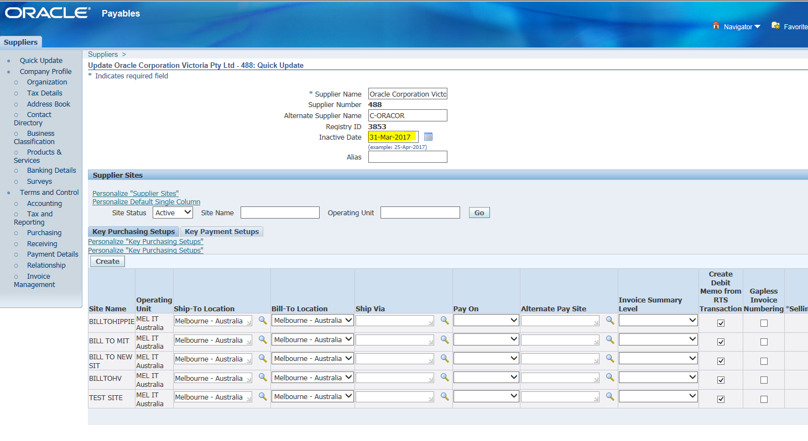

The new Supplier and Site will then be available for MIT OFC Payables invoice and payment processing.

Forward the above Alert Email to the relevant people and advise that the Supplier Site is active and available for processing when you have removed the Inactive Date.

Outstanding Issues

Alert Email Scheduling
We can schedule the Alert email to occur whenever the supplier site table has a new record inserted, or at selected intervals, for example 2 hours.

